**Counter Strange Explanation and Solution**

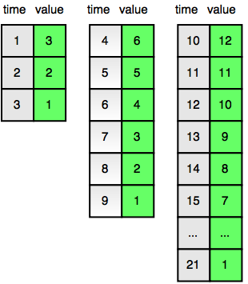

Majority of the people had given a correct solution; however, it was not an optimized solution. Hence, you’ll might have received **Time Limit Exceeded**.

**General Solution**: This will result in Time Limit Exceeded

1. Initialize Counter to 3.

2. Decrement Counter by 1 with increase in each second. When the counter reaches 1, multiply the initial value of the counter by 2.

3. Continue this till you reach the required time.

**Optimized Solution**:

1. Initialize Counter to 3

2. While t is greater than the counter, subtract counter from t and multiply counter with 2.

3. Final answer will be counter – t + 1

4. Simulation

t = 12

counter = 3

Since 12 > 3, t=12-3=9, counter=2*3=6

Since 9 > 6, t=9-6=3, counter=2*6=12

Since t is not greater than counter, final answer will be 12 – 3 + 1 = 10

**C++ Solution**:

#include <iostream>

using namespace std;

int main() {

long long int t;

long long int ticker = 3;

cin >> t;

while(t > ticker){

t -= ticker;

ticker *= 2;

}

cout << ticker-t+1;

return 0;

}

**Java Solution**

import java.util.*;

class Main {

public static void main(String[] args) {

Scanner sc = new Scanner(System.in);

long t = sc.nextLong();

long ticker = 3;

while(t > ticker){

t -= ticker;

ticker *= 2;

}

System.out.println(ticker - t + 1);

}

}

**Python Solution**

t = int(input())

ticker = 3

while(t > ticker):

t -= ticker

ticker *= 2

print(ticker - t + 1)